Nandida Valsaraj

2. 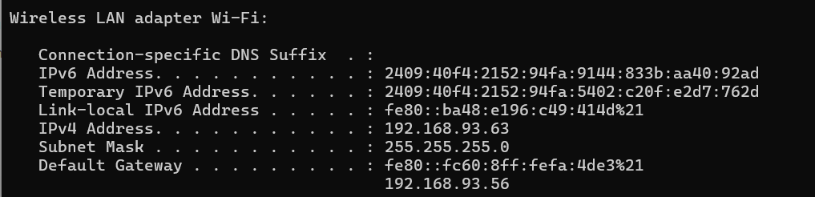

3,4. 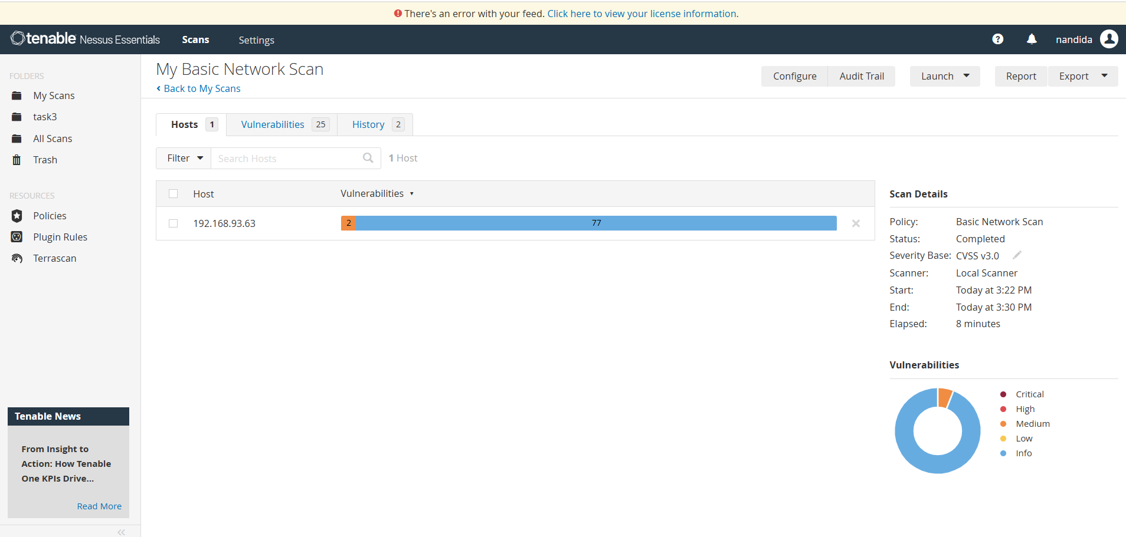

5. 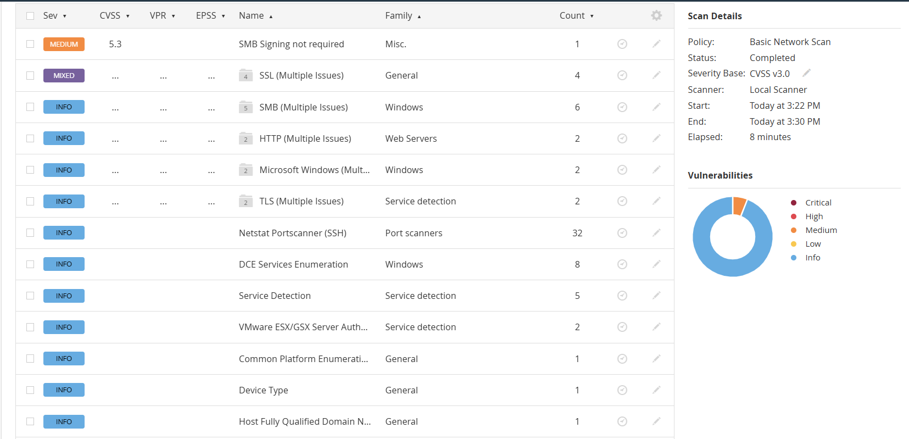

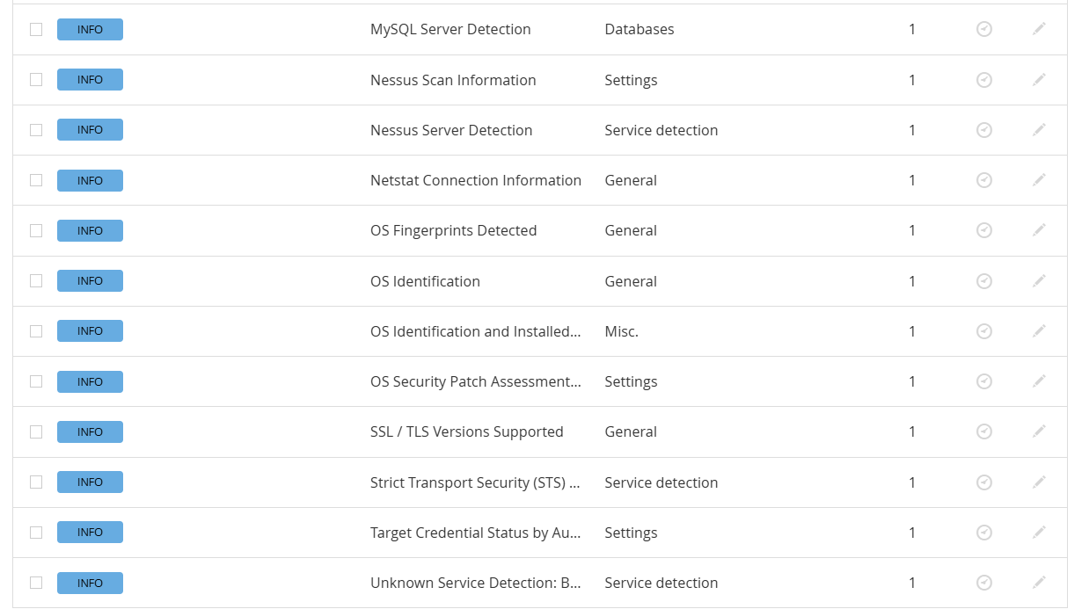

6. 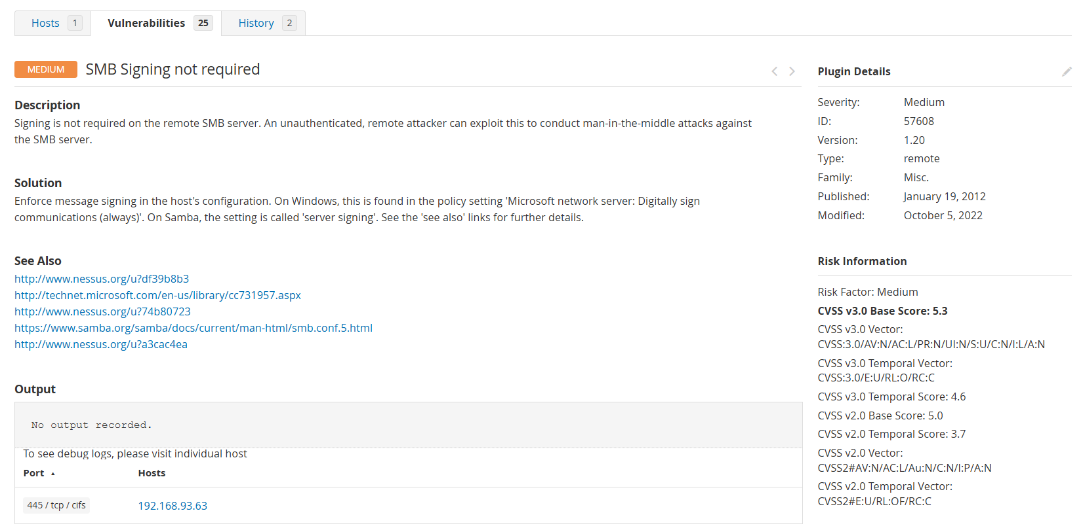**SMB (Server Message Block)** is a protocol used for sharing files, printers, and more between computers on a network.

SMB Signing not being required means that the server is not enforcing message signing for Server Message Block (SMB) traffic. This can create a security vulnerability, as it allows attackers to potentially intercept or modify SMB traffic, leading to man-in-the-middle attacks.

To address this vulnerability, it's recommended to enable SMB signing on the server.

 SMB signing adds a digital signature to each SMB message. It ensures:

* Integrity
* Authenticity
* Protection from spoofing and MITM attacks

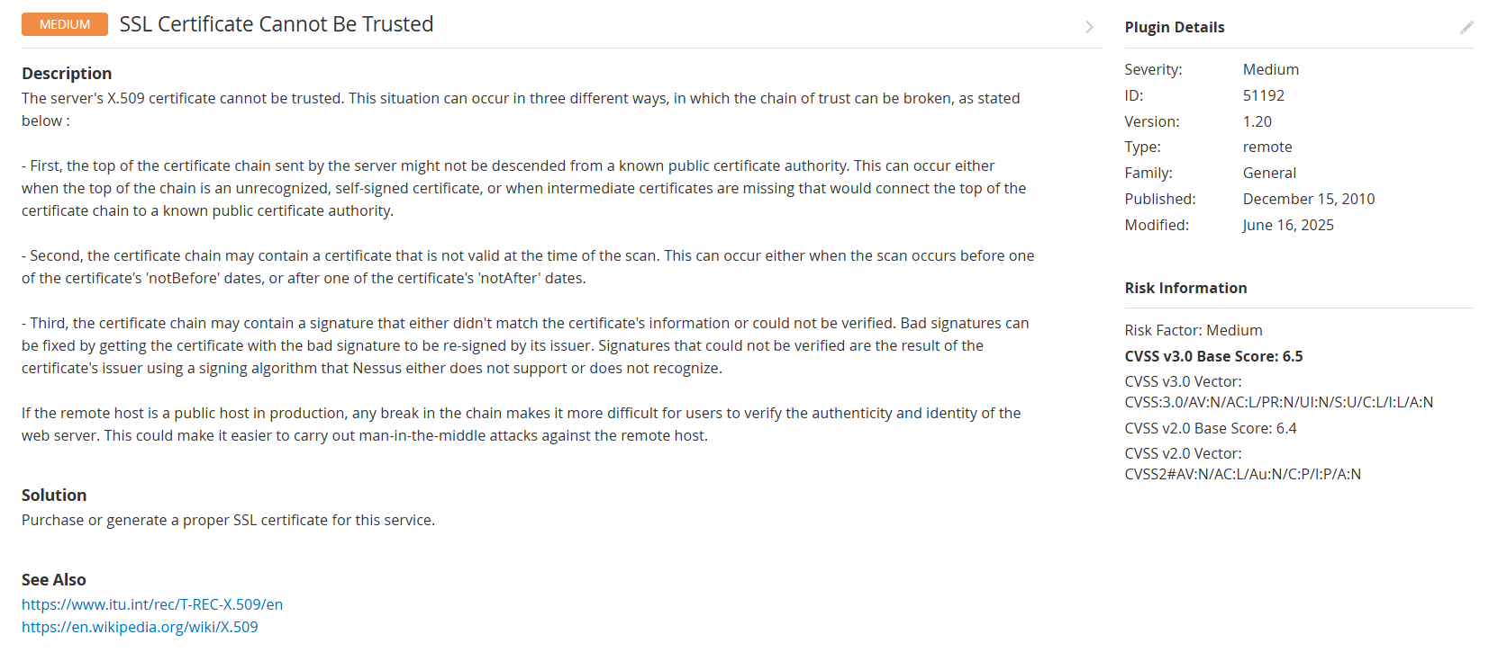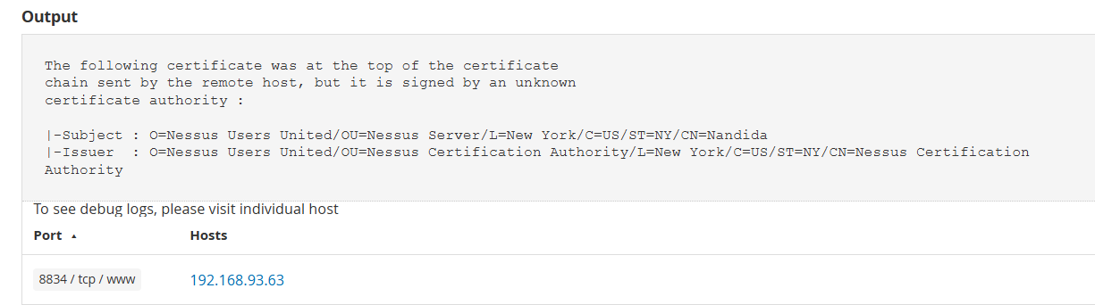

An SSL certificate cannot be trusted error means your browser or device doesn't recognize or trust the website's security certificate, preventing a secure connection.

Common causes of this error:

* Self-signed certificates
* Expired certificates
* Untrusted Certificate Authority
* Broken Certificate Chain

To fix the error

* Check your system date and time
* Update your browser and operating system
* Verify the certificate details
* Temporarily disable security features
* Clear browser cache and cookies

7.

* SMB Signing Not Required (Medium Vulnerability)
* SSL Certificate Cannot Be Trusted (Medium Vulnerability)

8. 